1. **Introduction**
   1. **Abstract**
      1. The following documentation will involve the instructions for compiling the software for an android operating system. The requirements to complete these instructions include: Java 1_8_0_202, Gradle, Android Studio (3.5.3), and the AVD Manager for Android (Needed the software is to be emulated on the computer). The steps involved include setting up a compile configuration, creating the Android APK file, and then installing the file for use on an android device. See also: https://stackoverflow.com/questions/16709848/build-unsigned-apk-file-with-android-studio
   2. Step 1: Setup the Run/Debug Configurations
      1. Go to Run>EditConfigurations…

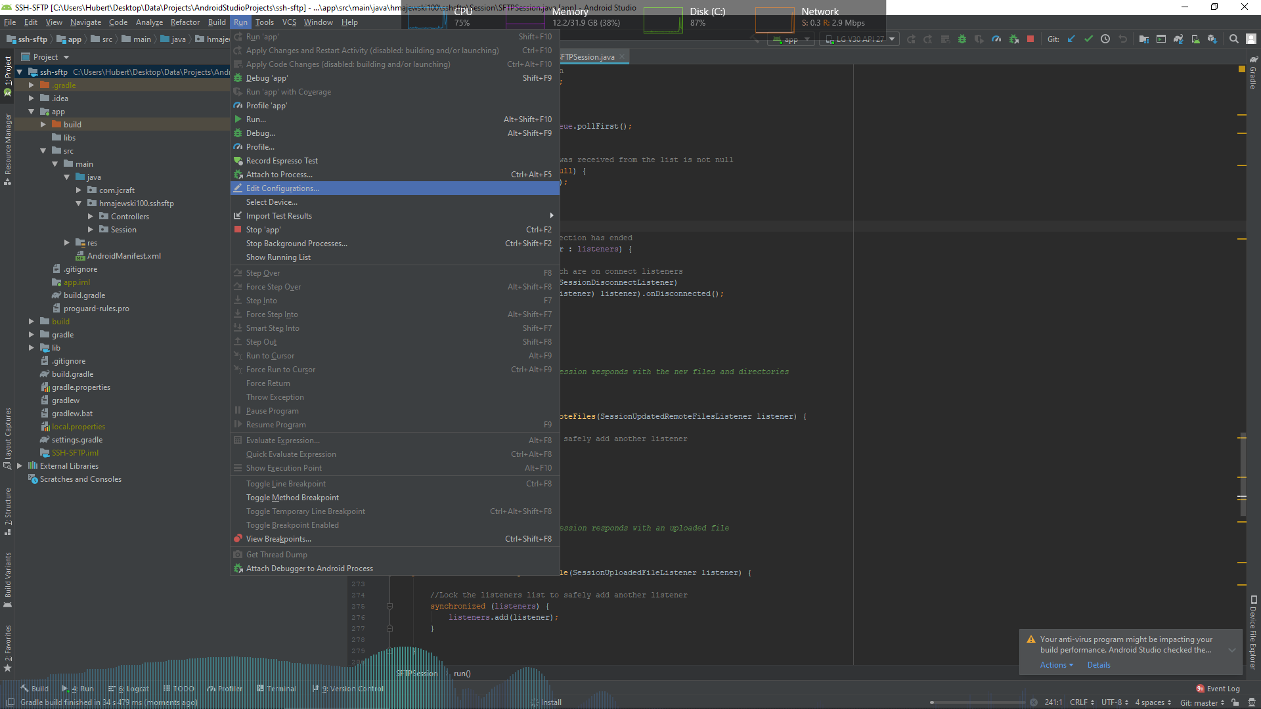

* + 1. Select the “+” and select “Gradle-aware Make”

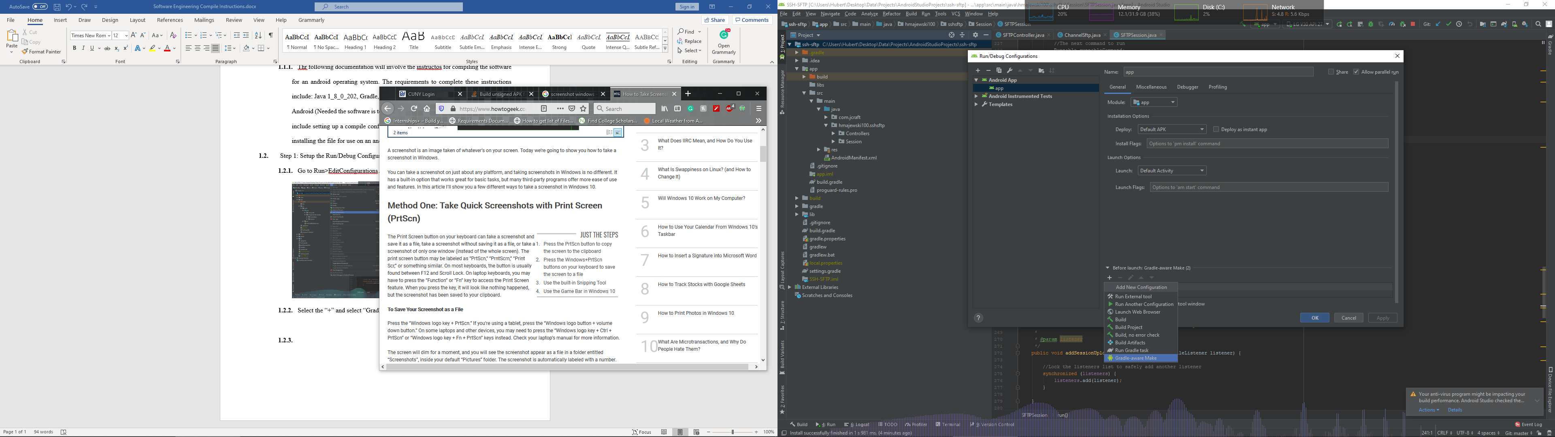

* + 1. Type “:app:assemble” to create a Gradle assembler

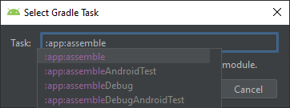

* + 1. Go to Run>Run app to compile the application
    2. The result will be found in (Android Proj. Dir.)/app/build/outputs/apk/
    3. How you can have the .apk file on an android device, install it and run the application.
  1. If you have established an AVD in android studio, you can press run and the application will run in the android emulator.